https://chatgpt.com/g/g-p-6a5378cdfc588191b929a3b5ca9c1c9a-itm-nextjs/c/6a6aea6e-6794-83e8-a9d3-22852803845a

Final behavior
The controls will always appear:
[Vertical Bar Chart ▼] [7 Days] [30 Days] [3 Months]
Selecting a range will update:
- Bar chart: total Opened and Closed for the range, plus latest Running and Procurement workload.
- Area chart: daily or monthly trend across the range.
- Pie chart: Opened versus Closed distribution for the range.
The four cards at the top should remain live current values:
Opened Today | Closed Today | Running TT | Procurement TT

http://127.0.0.1:8080/api/v1/dashboard/trouble-ticket-overview?range=3m
{
"data": {
"items": [
{
"label": "Jun 2026",
"open": 0,
"in_progress": 33,
"closed": 139
},
{
"label": "Jul 2026",
"open": 5,
"in_progress": 48,
"closed": 129
},
{
"label": "Aug 2026",
"open": 0,
"in_progress": 0,
"closed": 0
}
],
"range": "3m",
"total": 354
},
"success": true
}

http://127.0.0.1:8080/api/v1/dashboard/trouble-ticket-overview?range=7d
{
"data": {
"items": [
{
"label": "27 Jul",
"open": 2,
"in_progress": 0,
"closed": 0
},
{
"label": "28 Jul",
"open": 0,
"in_progress": 0,
"closed": 0
},
{
"label": "29 Jul",
"open": 0,
"in_progress": 0,
"closed": 0
},
{
"label": "30 Jul",
"open": 0,
"in_progress": 0,
"closed": 0
},
{
"label": "31 Jul",
"open": 0,
"in_progress": 0,
"closed": 0
},
{
"label": "01 Aug",
"open": 0,
"in_progress": 0,
"closed": 0
},
{
"label": "02 Aug",
"open": 0,
"in_progress": 0,
"closed": 0
}
],
"range": "7d",
"total": 2
},
"success": true
}

http://127.0.0.1:8080/api/v1/dashboard/trouble-ticket-overview?range=30d

{
"data": {
"items": [
{
"label": "04 Jul",
"open": 0,
"in_progress": 0,
"closed": 0
},
{
"label": "05 Jul",
"open": 0,
"in_progress": 1,
"closed": 7
},
{
"label": "06 Jul",
"open": 0,
"in_progress": 1,
"closed": 4
},
{
"label": "07 Jul",
"open": 0,
"in_progress": 2,
"closed": 7
},
{
"label": "08 Jul",
"open": 0,
"in_progress": 2,
"closed": 11
},
{
"label": "09 Jul",
"open": 0,
"in_progress": 1,
"closed": 2
},
{
"label": "10 Jul",
"open": 0,
"in_progress": 0,
"closed": 0
},
{
"label": "11 Jul",
"open": 0,
"in_progress": 0,
"closed": 2
},
{
"label": "12 Jul",
"open": 0,
"in_progress": 2,
"closed": 4
},
{
"label": "13 Jul",
"open": 0,
"in_progress": 1,
"closed": 10
},
{
"label": "14 Jul",
"open": 0,
"in_progress": 6,
"closed": 13
},
{
"label": "15 Jul",
"open": 0,
"in_progress": 5,
"closed": 8
},
{
"label": "16 Jul",
"open": 0,
"in_progress": 4,
"closed": 6
},
{
"label": "17 Jul",
"open": 0,
"in_progress": 1,
"closed": 0
},
{
"label": "18 Jul",
"open": 0,
"in_progress": 0,
"closed": 0
},
{
"label": "19 Jul",
"open": 0,
"in_progress": 5,
"closed": 17
},
{
"label": "20 Jul",
"open": 0,
"in_progress": 3,
"closed": 8
},
{
"label": "21 Jul",
"open": 0,
"in_progress": 2,
"closed": 11
},
{
"label": "22 Jul",
"open": 1,
"in_progress": 2,
"closed": 2
},
{
"label": "23 Jul",
"open": 0,
"in_progress": 3,
"closed": 4
},
{
"label": "24 Jul",
"open": 0,
"in_progress": 2,
"closed": 0
},
{
"label": "25 Jul",
"open": 0,
"in_progress": 0,
"closed": 1
},
{
"label": "26 Jul",
"open": 2,
"in_progress": 3,
"closed": 3
},
{
"label": "27 Jul",
"open": 2,
"in_progress": 0,
"closed": 0
},
{
"label": "28 Jul",
"open": 0,
"in_progress": 0,
"closed": 0
},
{
"label": "29 Jul",
"open": 0,
"in_progress": 0,
"closed": 0
},
{
"label": "30 Jul",
"open": 0,
"in_progress": 0,
"closed": 0
},
{
"label": "31 Jul",
"open": 0,
"in_progress": 0,
"closed": 0
},
{
"label": "01 Aug",
"open": 0,
"in_progress": 0,
"closed": 0
},
{
"label": "02 Aug",
"open": 0,
"in_progress": 0,
"closed": 0
}
],
"range": "30d",
"total": 171
},
"success": true
}

Showing this Dashboard View Currently
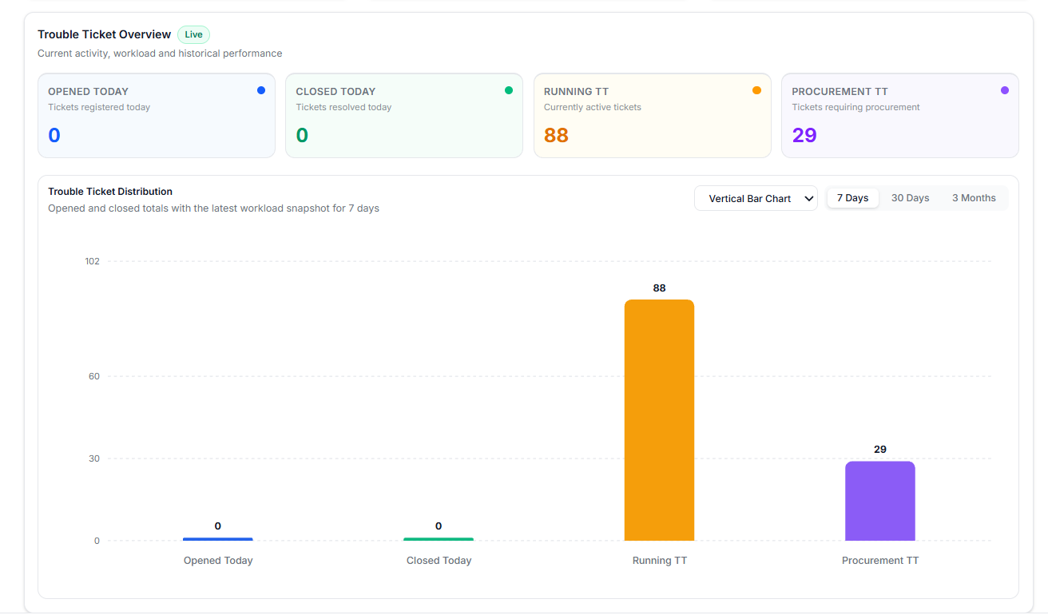

Fix the vertical bar chart now
The Bar chart should use the verified summary values for all four columns. In overview-chart.tsx, replace your complete selectedRangeData block with:
const selectedRangeData =
useMemo<TroubleTicketMetric[]>(
() => [
{
label: "Opened Today",
shortLabel: "Opened Today",
description: "Tickets registered today",
value: ticketSummary.opened_today,
color: COLORS.opened,
dotClass: "bg-blue-600",
valueClass:
"text-blue-600 dark:text-blue-400",
borderClass:
"border-t-blue-600",
backgroundClass:
"bg-blue-50/50 dark:bg-blue-950/10",
},
{
label: "Closed Today",
shortLabel: "Closed Today",
description: "Tickets resolved today",
value: ticketSummary.closed_today,
color: COLORS.closed,
dotClass: "bg-emerald-500",
valueClass:
"text-emerald-600 dark:text-emerald-400",
borderClass:
"border-t-emerald-500",
backgroundClass:
"bg-emerald-50/50 dark:bg-emerald-950/10",
},
{
label: "Running TT",
shortLabel: "Running TT",
description: "Current running workload",
value:
ticketSummary.total_running_tt,
color: COLORS.running,
dotClass: "bg-amber-500",
valueClass:
"text-amber-600 dark:text-amber-400",
borderClass:
"border-t-amber-500",
backgroundClass:
"bg-amber-50/50 dark:bg-amber-950/10",
},
{
label: "Procurement TT",
shortLabel: "Procurement TT",
description:
"Current procurement workload",
value:
ticketSummary.total_procurement_tt,
color: COLORS.procurement,
dotClass: "bg-violet-500",
valueClass:
"text-violet-600 dark:text-violet-400",
borderClass:
"border-t-violet-500",
backgroundClass:
"bg-violet-50/50 dark:bg-violet-950/10",
},
],
[ticketSummary]
);
After this change, the Bar chart will correctly show 0, 0, 88, 29, regardless of whether historical data is ready.
Area and Pie charts
The three range buttons require the overview endpoint:
/dashboard/trouble-ticket-overview?range=7d
/dashboard/trouble-ticket-overview?range=30d
/dashboard/trouble-ticket-overview?range=3m

The Area chart needs multiple dated records:
[
{
"label": "27 Jul",
"opened": 2,
"closed": 1,
"running": 85,
"procurement": 27
},
{
"label": "28 Jul",
"opened": 3,
"closed": 2,
"running": 86,
"procurement": 28
}
]
The Pie chart should use the selected range’s Opened versus Closed totals. Running and Procurement should not be combined into that pie because those two legacy conditions can overlap.
So the summary endpoint is confirmed working. The next required check is the Postman response from:
GET /api/v1/dashboard/trouble-ticket-overview?range=7d

The dashboard now looks much better, and the bar chart is correctly showing:
- Opened Today: 0
- Closed Today: 0
- Running TT: 88
- Procurement TT: 29
There is one important accuracy issue in the current view:
“Opened and closed totals with the latest workload snapshot for 7 days”
The bar chart is currently using live summary values, not seven-day values. Therefore, selecting 7 Days, 30 Days, or 3 Months will not meaningfully change the Running and Procurement bars unless the historical endpoint provides those values.
Recommended professional behavior
Keep the range buttons permanently visible, but apply them as follows:
Chart | Correct data
Vertical Bar | Opened and Closed totals for selected range, plus latest Running and Procurement snapshot
Area Chart | Daily/monthly trend for all four values
Pie Chart | Opened versus Closed totals for selected range
KPI cards | Always current live values: 0, 0, 88, 29
Current screenshot status
Your vertical bar chart layout is now correct and professional:
- Bars are vertical.
- Colors match the KPI cards.
- Values are shown above bars.
- The chart selector and range buttons are aligned correctly.
- Zero values are still visible.
- The chart scale automatically supports the highest value.
What to test next
Select:
Area Chart
Then test all three:
7 Days
30 Days
3 Months
The area chart should show dated points such as:
{
"label": "02 Aug",
"opened": 0,
"closed": 0,
"running": 88,
"procurement": 29
}
Then select:
Pie Chart
The pie chart should show Opened versus Closed for the selected period. Since both values are currently zero, it should show the professional empty state rather than an empty or misleading pie.
Fix the bar-chart description
For the current implementation, replace the Bar description with:
return "Current Trouble Ticket operational values";
So your complete function should be:
function getChartDescription() {
if (chartType === "area") {
return `Historical ticket activity and workload for ${selectedRangeLabel.toLowerCase()}`;
}

if (chartType === "pie") {
return `Opened versus closed ticket activity for ${selectedRangeLabel.toLowerCase()}`;
}

return "Current Trouble Ticket operational values";
}
This removes the misleading “for 7 days” wording while keeping the permanent range buttons available for switching to Area and Pie views.

